**Hafaliadau Cydamserol**

CBAC Haf 2009 Mathemateg Ychwanegol Papur 1

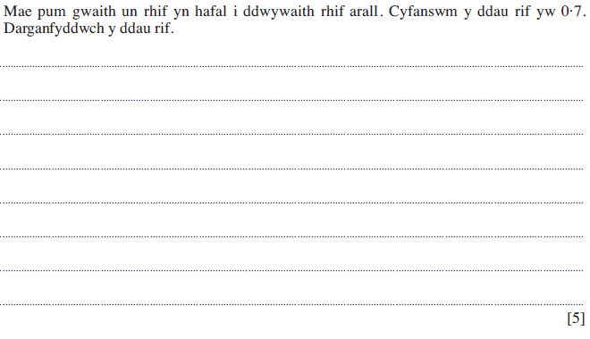

CBAC Haf 2010 Mathemateg Ychwanegol Papur 1

